**PROGRAM 2:**

**Extend the lexical Analyzer to Check comments, dened as follows in C:**

**a) A comment begins with // and includes all characters until the end of that line.**

**b) A comment begins with /* and includes all characters through the next occurrence of the character sequence */Develop a lexical Analyzer to identify whether a given line is a comment or not.**

**CODE:-**

**#include <stdio.h>**

**#include <string.h>**

**#define MAX_LINE_LENGTH 1024**

**int is_comment(const char *line) {**

**if (strncmp(line, "//", 2) == 0) return 1;**

**if (strstr(line, "/*") != NULL && strstr(line, "*/") != NULL) return 1;**

**return 0;**

**}**

**int main() {**

**char line[MAX_LINE_LENGTH];**

**printf("Enter a line of code: ");**

**fgets(line, sizeof(line), stdin);**

**printf(is_comment(line) ? "The line is a comment.\n" : "The line is not a comment.\n");**

**return 0;**

**}**

OUTPUT:-

a)

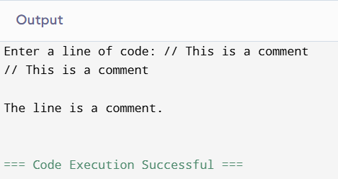

b)

